Week 4 The two sense path finder
08/12/2025
Universal Asynchronous Receiver-Transmitter (UART)
UART, or Universal Asynchronous Receiver-Transmitter, is a simple approach to serial communication that allows the host to communicate with an auxiliary device. UART supports only asynchronous and serial data transmission using two data lines, one to transmit (TX) and the other to receive (RX). Data can be transmitted either in one direction (unidirectional) or in both directions (bidirectional). Both the Arduino NANO and ESP32 microcontrollers have hardwired pins dedicated to the TX and RX lines for serial communication
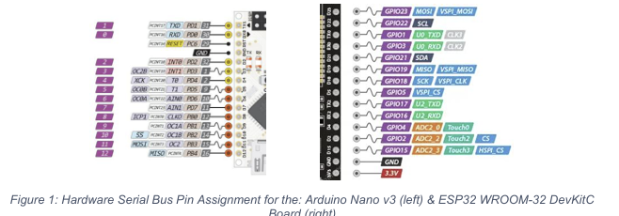

Software Serial
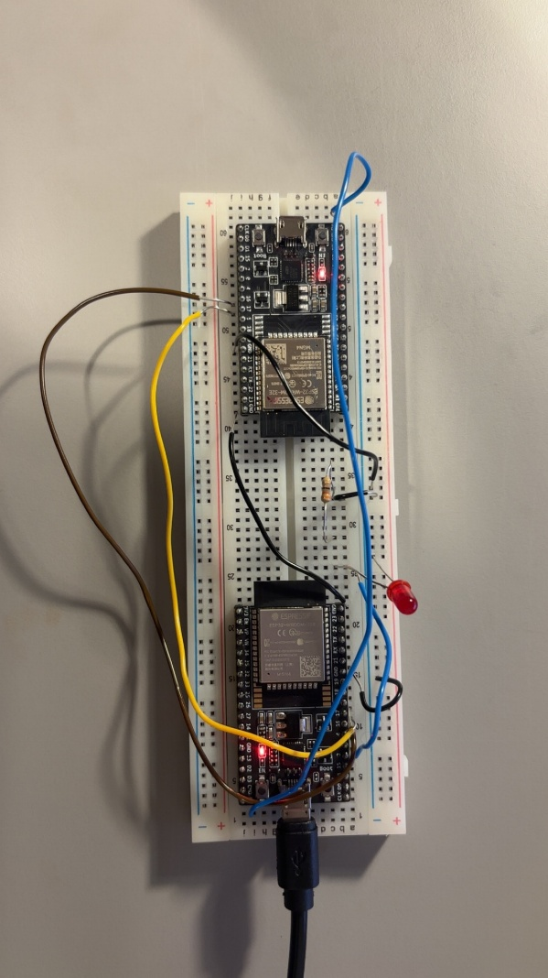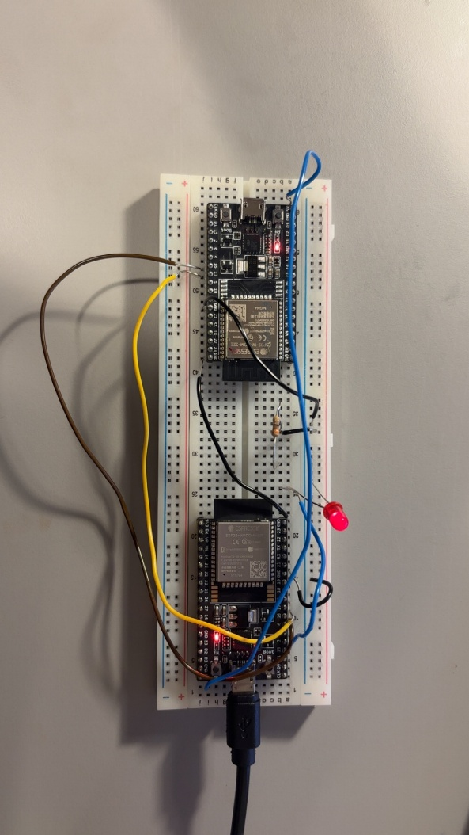
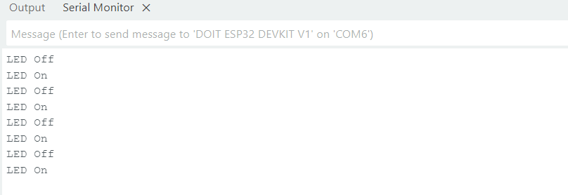

Serial Peripheral Interface (SPI
The Serial Peripheral Interface (SPI) is a synchronous, i.e. clock controlled, serial protocol used to communicate between other microcontrollers or other peripheral devices. It is a full duplex protocol, meaning that data is sent and received simultaneously, and is suited to communications over short distances. SPI is a synchronous communication protocol and so relies on the presence of a clock signal.
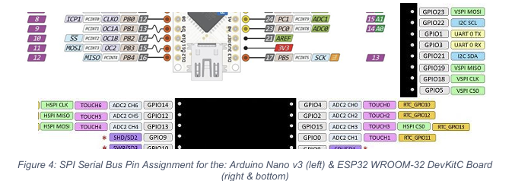

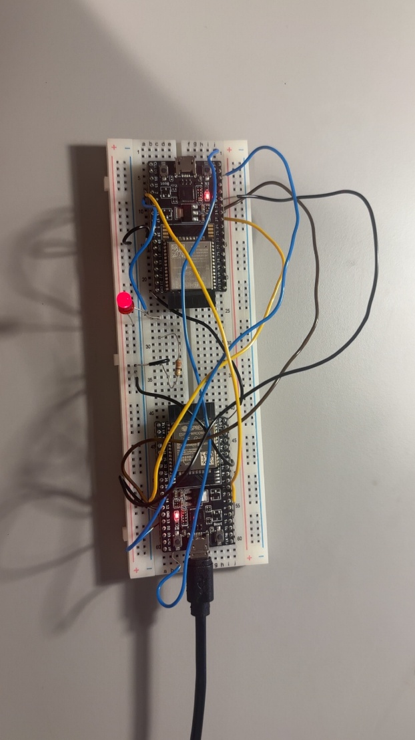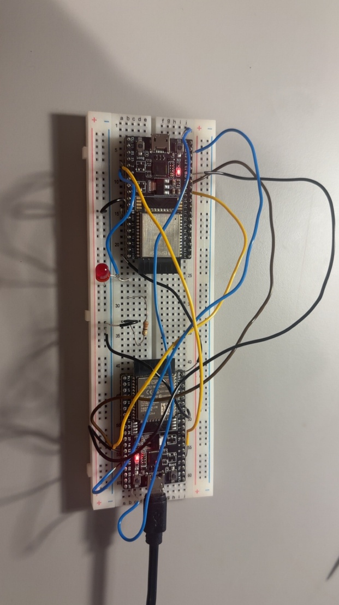
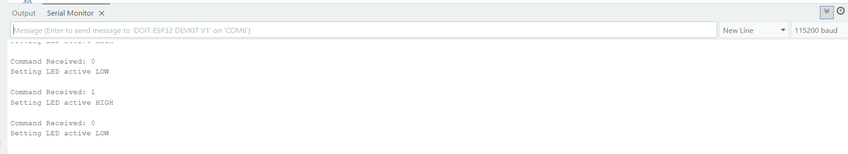
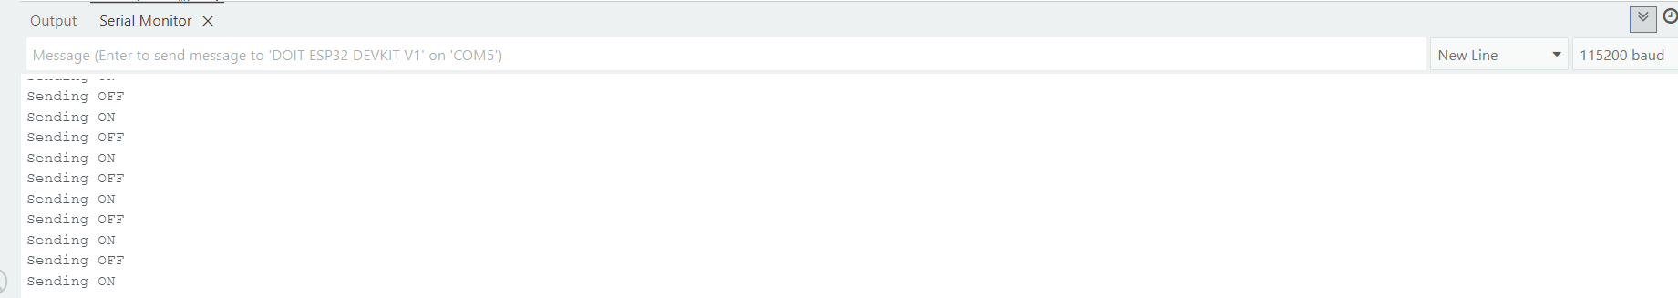
Inter-Integrated Circuit (I2C)
- In a typical implementation, communication takes place between a master and one or more slave devices.
- The bus requires two data lines, over which communication is established, and the specification allows for multiple devices to communicate on the same bus.
- SDA (Serial Data) and SCL (Serial Clock). Up to 112 devices, assuming 7-bit addressing is used, can communicate on the same two-wire bus. This is because each device on the bus will have a unique address that is used to choose which of the devices the master device communicates with.
- 2⁷ is 128, however, a number of addresses are reserved for specific commands and protocols, so cannot be used.
I2C on the Arduino NANO Microcontroller
For the Arduino Nano v3 that we are using for this example, the SDA and SCL lines are connected to the analogue IO pins, A4 and A5, respectively
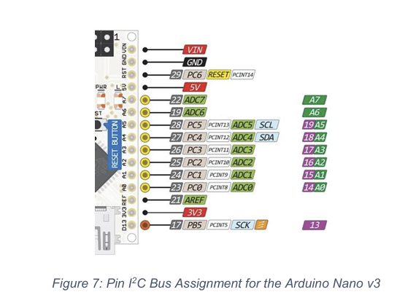
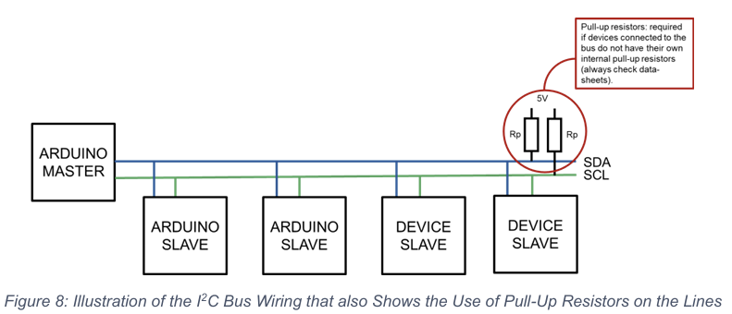
Master device can “read data from” or write data to” the slave devices on the bus. Each device will have its own unique address on the bus, which is used to direct the read/write requests to the intended device.
The Arduino ‘Wire’ library is used to control communications over the I2C bus, and the basic elements required for initialising the bus and for sending or receiving data are outlined in the following examples.
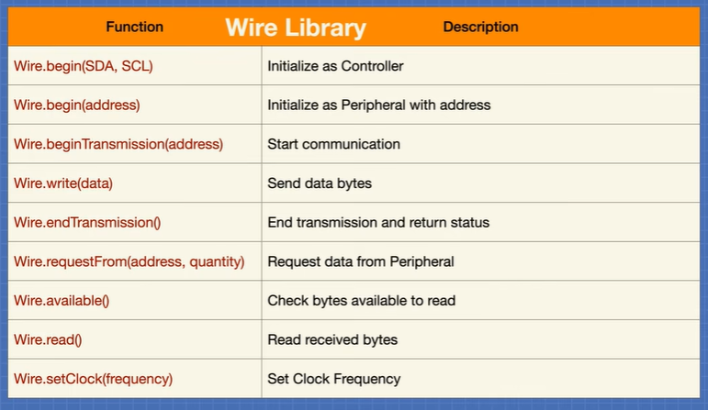
I2C on the ESP32 Microcontroller
I2C communication on the ESP32 is very similar to that on the Arduino boards, with a couple of aspects to consider. It is also worth noting that I2C communication can be done between an Arduino and ESP32, with either being the or the slave. The SDA and SCL pins on the Page 10 of 15 ESP32 are GPIO 21 and 22, respectively
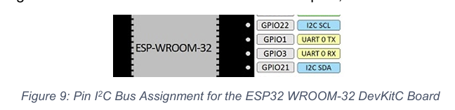
5 numbers average
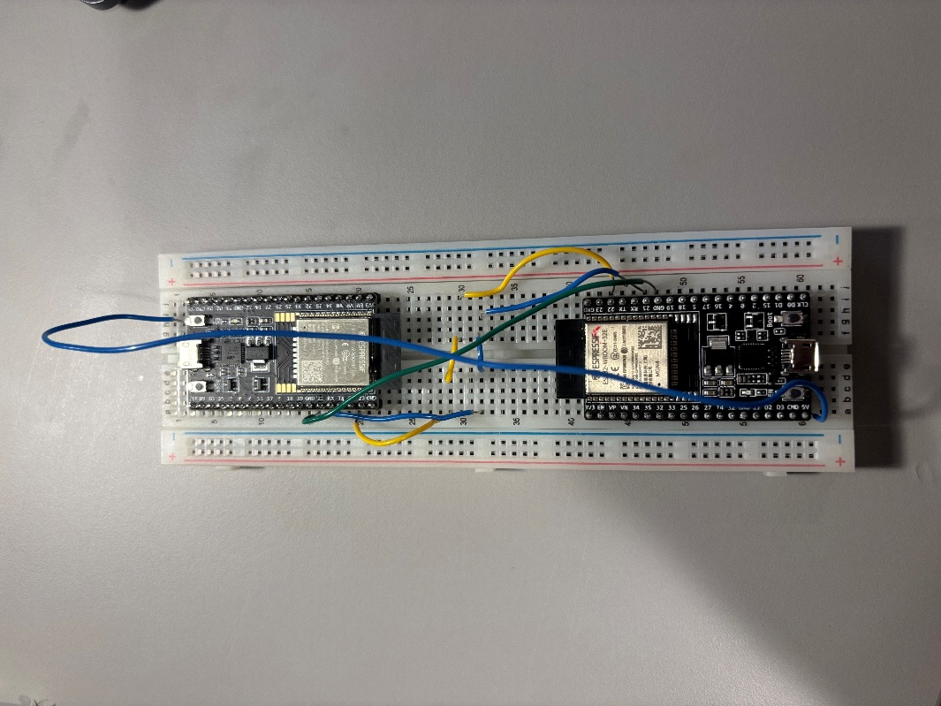
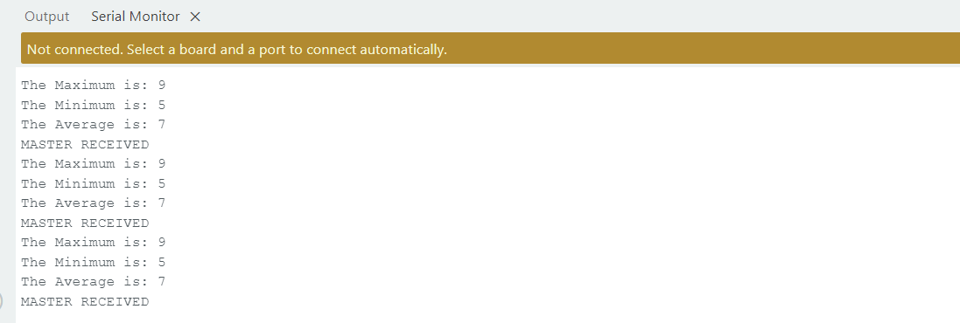
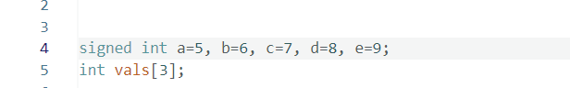
09/12/2025
Testing the Serial Communication Between Microcontrollers 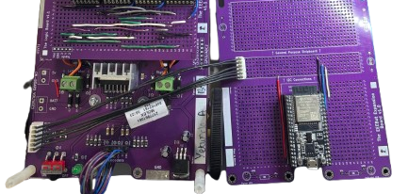
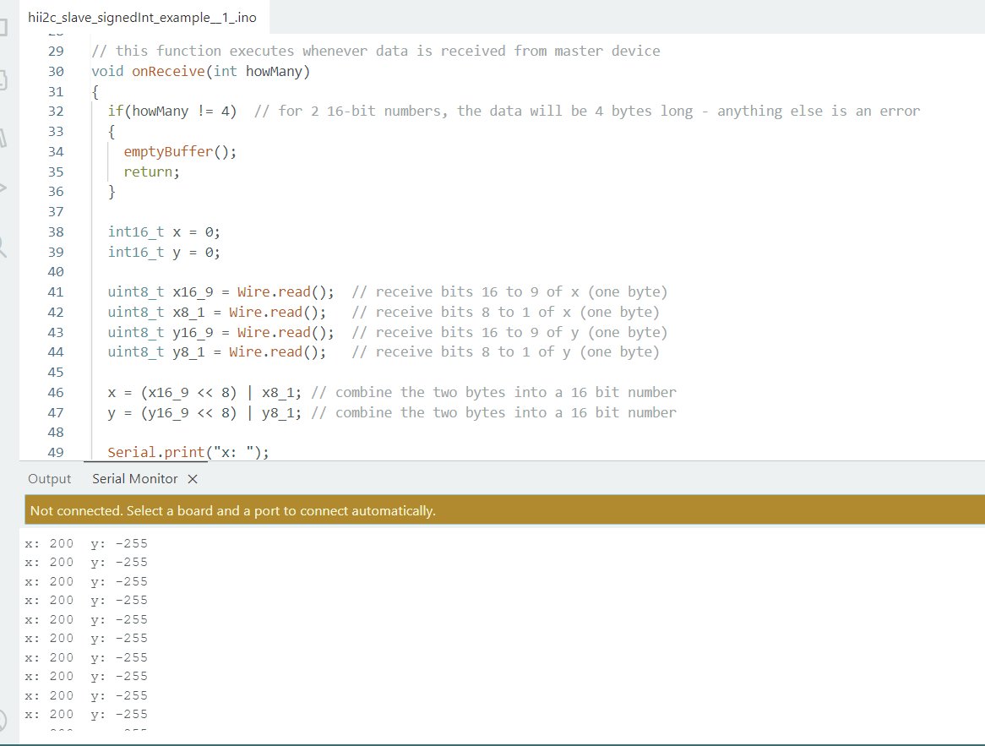

The Additional Sensor
a sensor is a device that can detect and respond to some type of input from the physical environment
Below, some key terms regarding sensor calibration are defined:
Error: the result of a measurement minus the true value of the measurand i.e. the departure from the true value.
There are two variations of measurement error:
Systematic Error, ES: the mean of many measurements minus the true value.
Random Error, ER: a measurement minus the mean of many measurements.
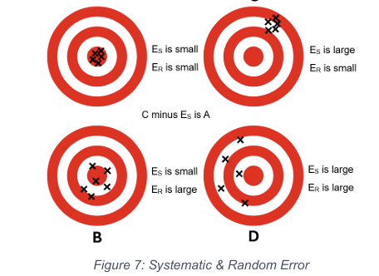
Precision: this refers to the similarity of successive measurements i.e. how close the measurements are to one another, regardless of the true value – the results are repeatable and have a small standard deviation.
Accuracy: this refers to the degree of correctness of a measurement i.e. how close the measurement is to the true value – the mean of the results is close to the actual value.
Tolerance: describes the maximum deviation of a manufactured component from some specified value. You have observed this when measuring the resistance of a resistor with a multimeter – the values are rarely identical! The last band on a resistor indicates its tolerance e.g. gold band (± 5%) or silver band (± 10%).
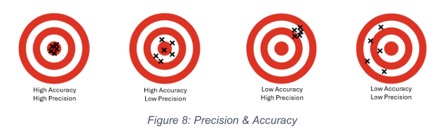

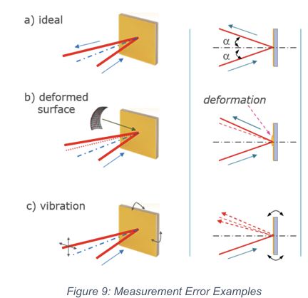

In a), the angle of incidence, α, is equal to the reflected angle, α. This is easy to predict, as depending on the mirror tilt, we know that ‘α in’ always equals ‘α out’.
In b), deformation has occurred. ‘α in’ no longer equals ‘α out’. As a result, it is very difficult to predict the result of tilting the mirror.
In c), vibration has occurred. The reflected beam has changed direction in a random manner, both temporally and in magnitude.

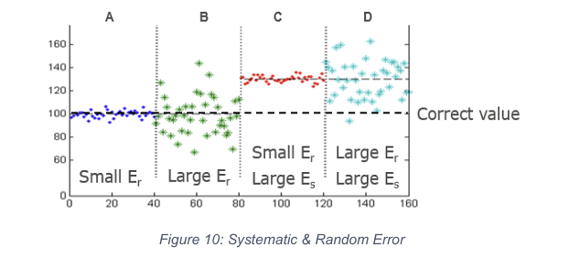
To minimise systematic errors, you need to use traceable reference samples to calibrate the system regularly, as well as ensuring that the designed operating environment is maintained. On the other hand, to minimise the random error, we may need to modify the system and/or control the operating environment to maintain the desired temperature, amount of vibration and the level of electrical interference
Presenting Results

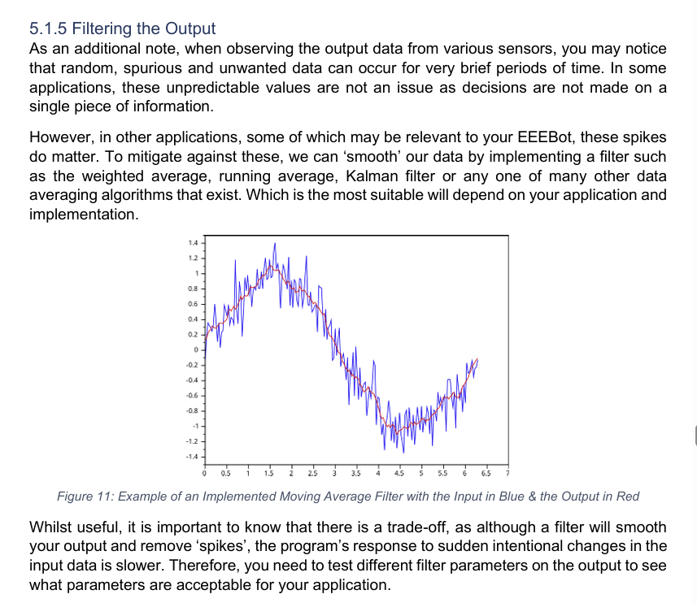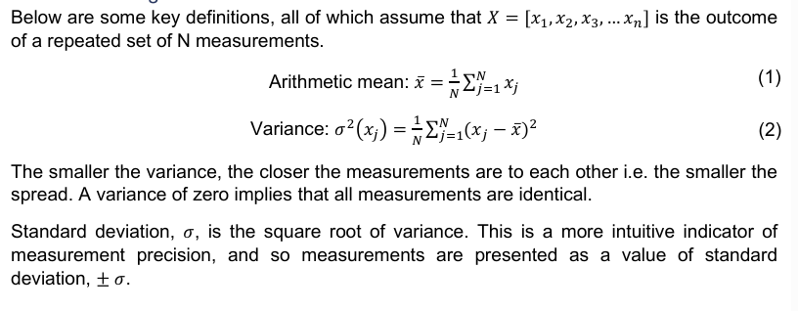

Calculating potential divider resistance
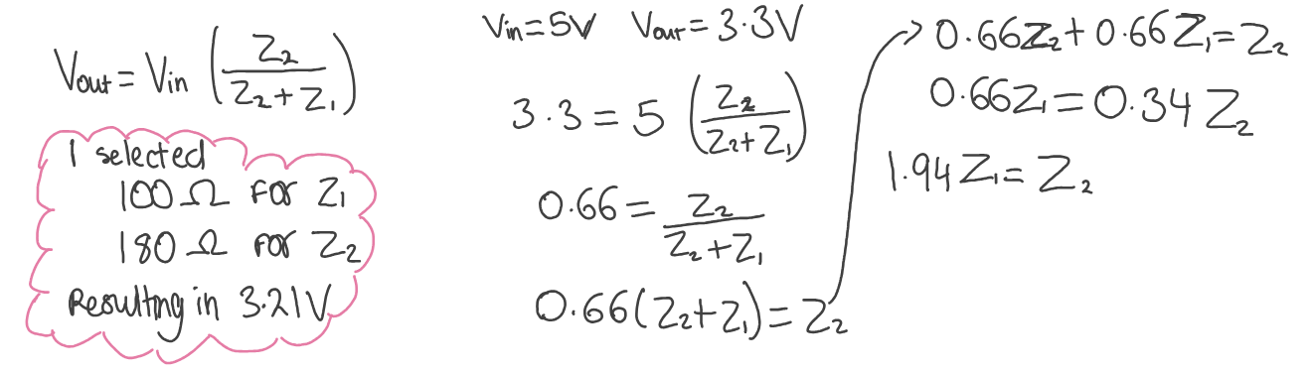

Ultrasonic sensor breadboard test
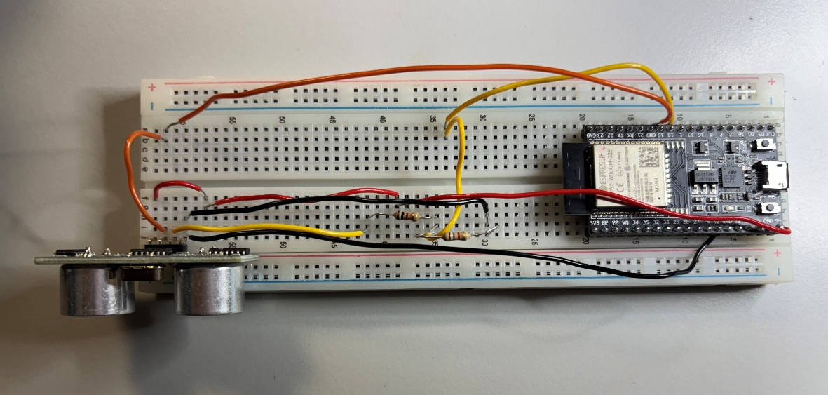
03.03 - NewPing Library for Ultrasonic Sensor | Experiments in Electronic Arts - 2025 Spring | Jimmy Kuehnle
Measuring Distance With HC-SR04 And ESP32 – A Practical Guide For Makers - ArduinoYard
HC-SR04 + NewPing Library: Measurement in millimeter? - Projects / Programming - Arduino Forum
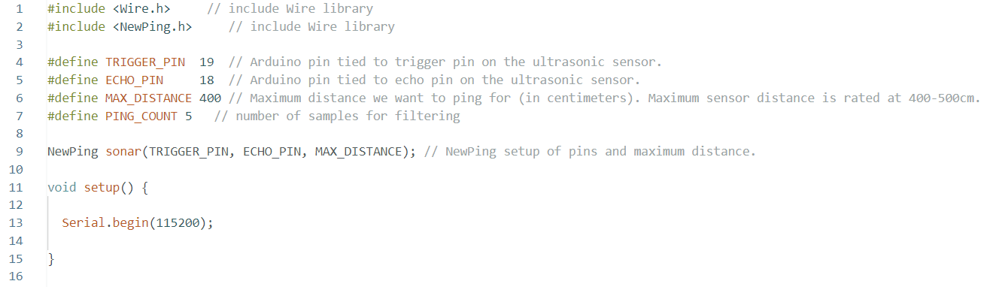
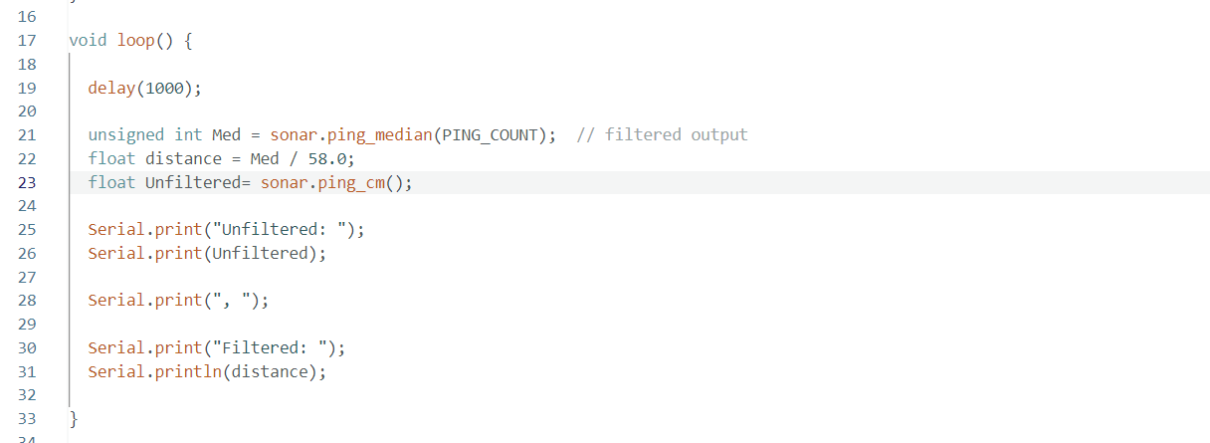
Serial monitor screenshot of me moving it closer to a wall
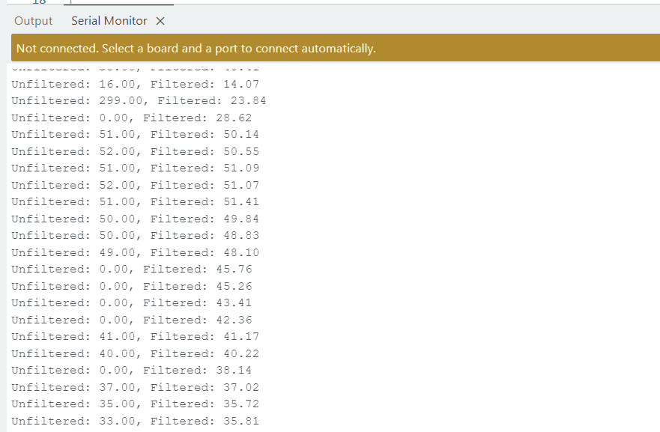

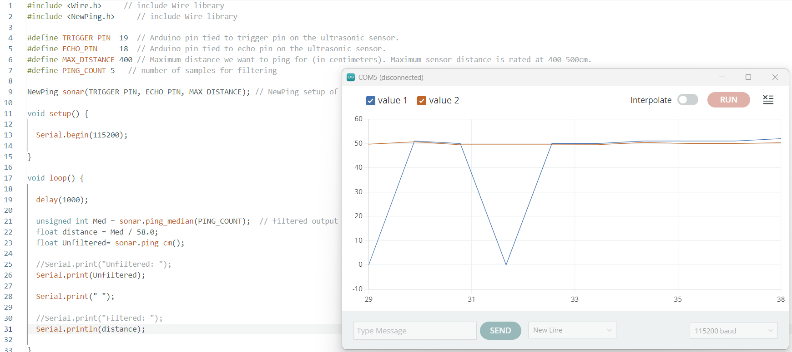
The serial plotter shows the unfiltered readings have inaccurate spikes whereas the filtered values remain consistent. I will use this median filtering in the maze.

I soldered this circuit onto the PCB however my LED circuit caused some issues in transmission as I accidentally connected 2 resistors from different circuits in series. Absolute torture figuring that out. All I had to do was cut the tracks.
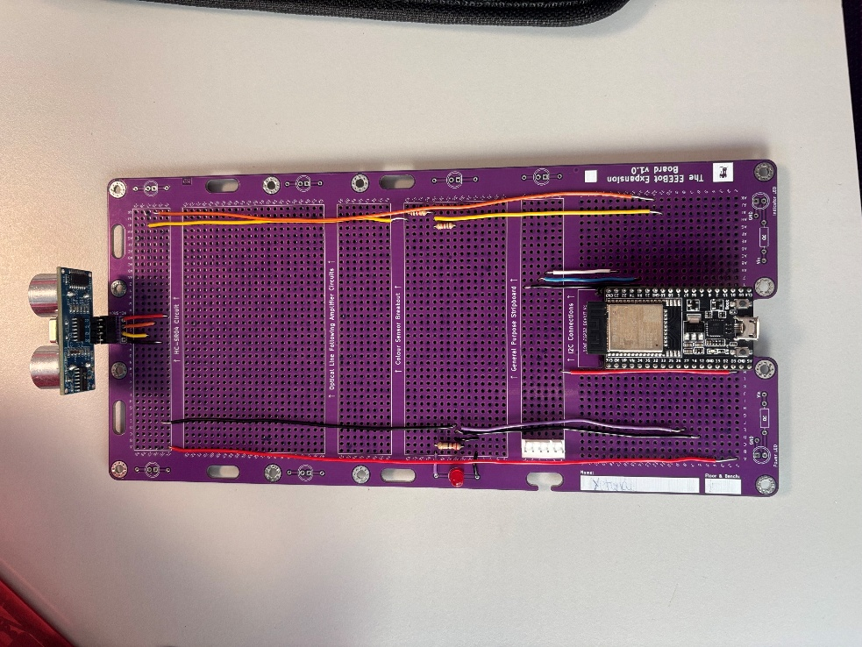

After trials and tribulations my program worked somewhat my only issues was it took too long to stop before turning. I realise now I should have slowed it down a whole lot. When doing my final testing my bot crashed and the header for the HC-SR04 sensor broke. Me being talented and resourceful I did everything in my power to connect the sensor and I succeeded. My result is below as well as my updated code with the speed lower
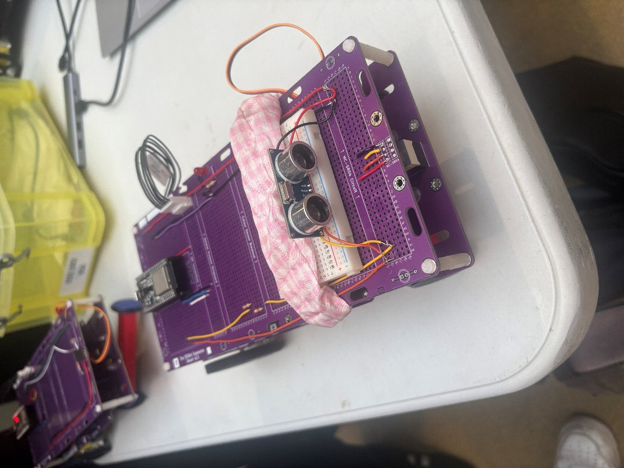

Master maze code


